Fabric Lakehouse in a Day

Introduction 3

What is Microsoft Fabric? 3

Purpose of This Workshop 3

OneLake and Lakehouse 3

End-to-End Architecture 4

Hands-On Scenario Walkthrough 5

Datasets 6

Getting Started with Fabric 6

Existing Power BI users 7

Users who are new to Power BI 7

Start the Fabric (Preview) trial 7

Other ways to start a Microsoft Fabric (Preview) trial 11

**Introduction**

## What is Microsoft Fabric?

Microsoft Fabric provides a one-stop shop for all the analytical needs of every enterprise. It covers the complete spectrum of services including data movement, data lake, data engineering, data integration and data science, real-time analytics, and business intelligence. With Microsoft Fabric, there is no need to stitch together different services from multiple vendors. Instead, enterprises enjoy an end-to-end, highly integrated, single comprehensive product that is easy to understand, onboard, create, and operate. Combined with Microsoft Purview, which is included by default in every tenant, the entire data estate can be centrally governed, ensuring compliance with all data policies. There is no other product on the market that offers the breadth, depth, and level of integration that Microsoft Fabric offers.

Learn more about [Microsoft Fabric](https://www.microsoft.com/en-us/microsoft-fabric)

## Purpose of This Workshop

The aim of this workshop is to guide individuals through a Data Engineering end-to-end scenario using Microsoft Fabric. While some concepts may be familiar to data and analytics professionals, applying them in a new environment can be challenging.

In this workshop, participants will learn how to build a Fabric Lakehouse using Delta Lake. They will gain hands-on experience with data engineering tasks such as data ingestion, data transformation, and data modeling. By the end of the workshop, participants will have a solid understanding of how to build a data pipeline using available Data Engineering options in Microsoft Fabric.

## OneLake and Lakehouse

Every Fabric tenant will always have exactly one OneLake, which is a unified logical SaaS data lake for the whole organization with data organized into domains. It prevents data silos and provides full and open access through industry-standard APIs and formats to any application, preventing platform lock-in. Within Fabric, new workspaces are created similar to how they are created with Azure Synapse or Power BI. All these workspaces are just folders within OneLake. Anything stored within a workspace gets stored in the workspace’s corresponding folder in OneLake. All data is ultimately under the control of a tenant administrator.

## End-to-End Architecture

|  |
| --- |
|  |

**Ingesting Data into a Lakehouse**

**Local file upload:**Uploading data directly from a local machine through the Lakehouse explorer or ingest from an Azure SQL database

**Notebook Code:** Using available spark libraries to connect to a data source directly and then loading data to dataframe and saving it in a lakehouse

**Copy Tool in Pipelines:** Connect to different data sources and land the data either in original format or convert it to a delta table

**Transformations:** Notebooks/Spark jobs/Dataflows can be used for data preparation, cleansing and transformations

**Storage:** Lakehouse, or Lakehouse(s) with medallion structure (Bronze/Silver/Gold)

**Exposure:** In Power BI via Direct Lake or SQL Endpoint

**Orchestration:** Pipelines triggering Notebooks

Hands-On Scenario Walkthrough

This comprehensive workshop has been meticulously crafted to guide you through a step-by-step journey, starting from the initial data acquisition all the way to data consumption. Our primary focus is on fostering a deep understanding of Microsoft Fabric.

The initial stage entails setting up your Fabric environment. You can either create a Fabric trial account or utilize your existing Power BI account, as explained in the subsequent section. Following this, you'll establish a dedicated Fabric workspace, where all your essential components such as lakehouses, warehouses, and reports will find their home.

Moving forward, you'll embark on a journey that adheres to the Medallion architecture by creating three distinct lakehouses – bronze, silver, and gold. These lakehouses will serve as the stages where your data undergoes transformations and enhancements.

The scenario illustrated the real-world example for Contoso, a fictitious company. Contoso is a retailer with thousands of brick-and-mortar stores across the world. They also have an online store. Contoso is acquiring Litware Inc. Litware has curated marketing data and sales data processed by Microsoft Fabric and stored in the gold layer in OneLake.

This lab has exercises on:

* Provision and configure resources
* Create a Fabric workspace and data pipeline
* Explore Copilot capabilities ( Optional , will required a paid Fabric capacity and will not work with Trial Fabric capacity)
* Implementing the Medallion Architecture using Azure Databricks (Bronze, Silver and Gold layers)
* Creating PBI reports
* Explore Additional Features

Starting with your bronze lakehouse, you'll ingest Sales data from Azure SQL DB or upload dataset into the Raw lakehouse from the data shared by the Microsoft team and perform necessary transformations and store the refined data as a delta table in the silver lakehouse.

Within the silver lakehouse, you'll take your sales data. Once again, the enriched data will be saved as a delta table. Subsequently, you'll progress to the gold lakehouse, where you'll further enrich your dataset, execute essential aggregations.

Finally, you'll conclude this immersive journey by harnessing the data you've prepared to create a compelling Power BI report, leveraging the capabilities of Direct Lake.

## Datasets

During this workshop we will use the dataset shared with you or use the Azure SQL DB dataset. The containers inside the storage account contain all the data we will need but for your reference the datasets we are using are:

Getting Started with Fabric

Microsoft Fabric is provided free of charge when you sign up for the Fabric trial. Your use of the Microsoft Fabric trial includes access to the Fabric product experiences and the resources to create and host Fabric items.

## Existing Power BI users

If you are an existing Power BI user, you can skip to [Start the Fabric (Preview) trial](https://learn.microsoft.com/en-us/fabric/get-started/fabric-trial#start-the-fabric-preview-trial).

## Users who are new to Power BI

For public preview, the Fabric (Preview) trial requires a Power BI license. Navigate to [https://app.fabric.microsoft.com](https://app.fabric.microsoft.com/) to sign up for a Power BI free license. Once you have a Power BI license, you can start the Fabric (Preview) trial.

## Start the Fabric (Preview) trial

Follow these steps to start your Fabric (Preview) trial.

Open the [Fabric homepage](https://app.fabric.microsoft.com/home) and select the Account manager.

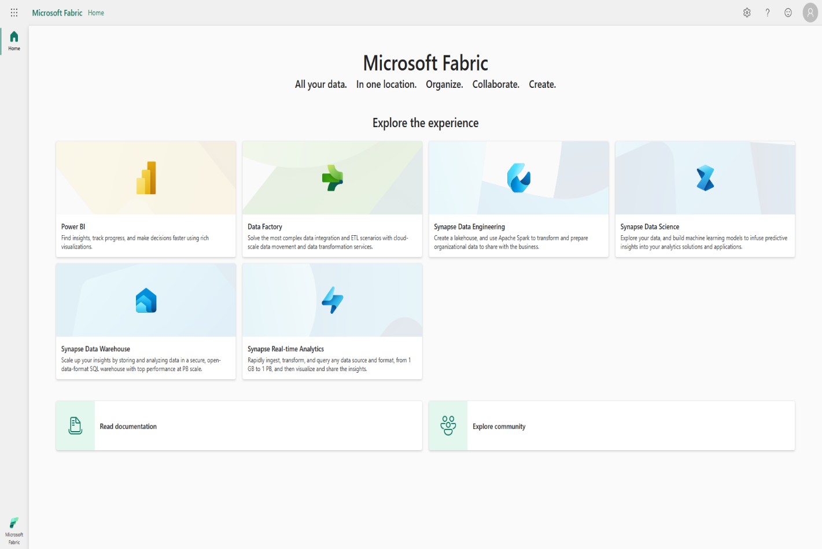

In the Account manager, select Start trial. If you don't see the Start trial button, trials may be disabled for your tenant. To enable trials for your tenant, see [Administer user access to a Fabric (Preview) trial.](https://learn.microsoft.com/en-us/fabric/get-started/fabric-trial#administer-user-access-to-a-fabric-preview-trial)

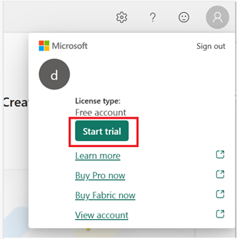

If prompted, agree to the terms and then select Start trial.

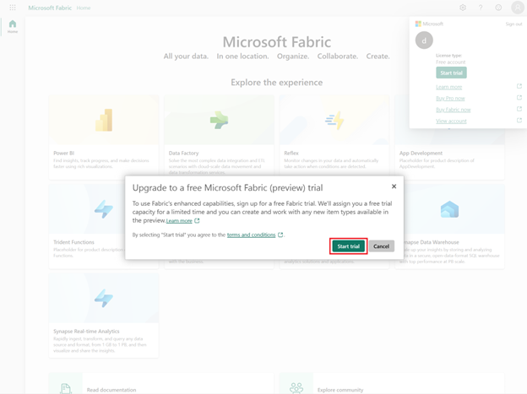

Once your trial capacity is ready, you receive a confirmation message. Select Got it to begin working in Fabric.

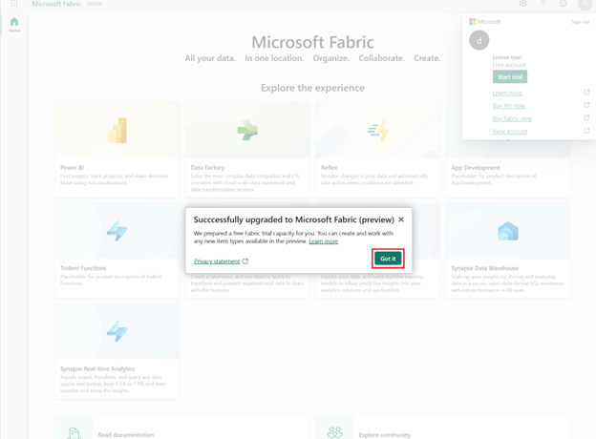

Open your Account manager again. Notice that you now have a heading for Trial status. Your Account manager keeps track of the number of days remaining in your trial. You also see the countdown in your Fabric menu bar when you work in a product experience.

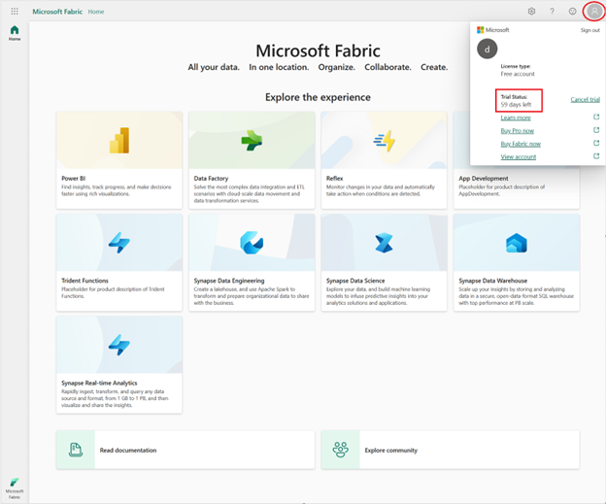

Congratulations! You now have a Fabric (Preview) trial that includes a Power BI individual trial (if you didn't already have a Power BI paid license) and a Fabric (Preview) trial capacity.

## Other ways to start a Microsoft Fabric (Preview) trial

If your Fabric administrator has [enabled the preview of Microsoft Fabric for the tenant](https://learn.microsoft.com/en-us/fabric/admin/fabric-switch#enable-for-your-tenant) but you do not have access to a capacity that has Fabric enabled, you have another option for enabling a Fabric (Preview) trial. When you try to create a Fabric item in a workspace that you own (such as My Workspace) and that workspace doesn't support Fabric items, you're prompted to start a Fabric (Preview) trial. If you agree, your Fabric (Preview) trial starts and your workspace is upgraded to a trial capacity workspace.

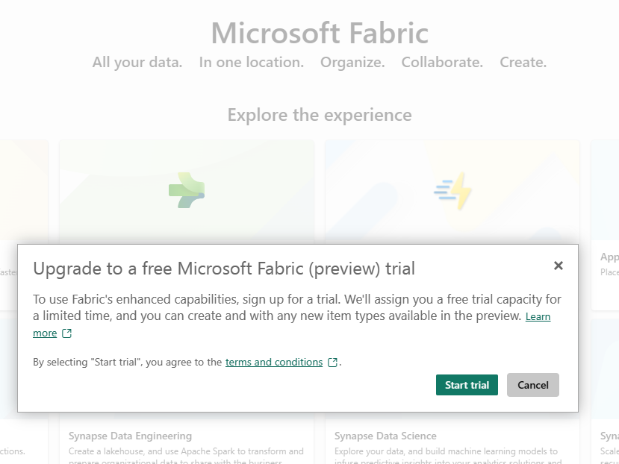

Getting Started with the Labs

As a next step get started with the labs using the links below . **DAY 1**

|  |  |  |  |  |
| --- | --- | --- | --- | --- |
| **Delivery Type** | **Name** | **Format** | **Resource location in the IP folder** | **Estimated**  **duration** |
| Presentation | MS Fabric Data Engineering Hands on walkthrough | Presentation  PPTX. | [https://aka.ms/DataAI-IP/Fabric-Lakehouse-Upskilling/](https://aka.ms/DataAI-IP/Fabric-Lakehouse-Upskilling) Assets/Day2/Deck/Fabric Lakehouse in a Day Hands-on.pptx | 30 mins |
| Hands-on training | MS Fabric Data Engineering Hands on workshop | Hands on workshop | [https://aka.ms/DataAI-IP/Fabric-Lakehouse-Upskilling/](https://aka.ms/DataAI-IP/Fabric-Lakehouse-Upskilling) Assets/Day2/Labs/Lab 0 - Provision and configure resources Option 1.pdf  or  Assets/Day2/Labs/ Lab 0 - Provision and configure resources Option 2 - Fabric only.pdf | 1-2hrs |

**DAY 2**

|  |  |  |  |  |
| --- | --- | --- | --- | --- |
| **Delivery**  **Type** | **Name** | **Format** | **Resource location in the IP folder** | **Estimated**  **duration** |
| Hands-on training | MS Fabric Data Engineering Hands on workshop | Hands on workshop | * [https://aka.ms/DataAI-IP/Fabric-Lakehouse-Upskilling/](https://aka.ms/DataAI-IP/Fabric-Lakehouse-Upskilling) Assets/Day2/Labs/Lab 1 - Create a Fabric workspace and data pipeline.pdf * Assets/Day2/Labs/Lab 2 - Explore Copilot capabilities.pdf * Assets/Day2/Labs/Lab 3 - Implement the Medallion Architecture.pdf * Assets/Day2/Labs/Lab 4 – Create PBI reports.pdf * Assets/Day2/Labs/Lab 5 - Explore Additional Features.pdf | 6-7 Hours |